Feb 21, 2021

In the figure below Kathy closed the door to the sunshine room at -12500 sec (about 3:00 am). The model heat disparity, heat_o, is headed for about -3000 after tracking filter overshoot settles or more which is the effect of loss of convection and the duct convection (duction). At -11000 I opened the door again, just a crack, and we gained back duction to settle at -1100. So duction is worth about 3000 BTU/hr. Then I opened the door fully at -6000 and we ended up at -750 so convection is worth about 400 BTU/hr.

This is all with the fan at full speed and the duct temperature drop measured at 4 F.

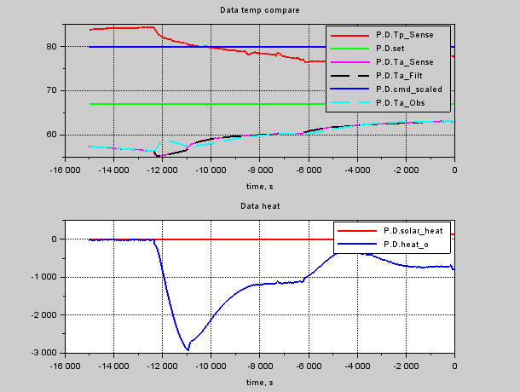

Even with Tp on the move, the heat_o stays constant saying the dynamics of that part of the model are mostly right. We may have to tune it later as the model gets better – I know there is an unmodeled lead effect in a addition to the modled lag. But note that the duct temperature loss in the model is currently at 7 F while I measured 4 F.

When the duct drop is incorporated, it would make the disparity about -1800 instead of -1100. So the air flow must be half of what’s modeled. The convection model should be modified to have about 500 BTU/hr at full duction. The offset model (Qlk) should be increased by 1000 BTU/hr. This test should be re-run the next day with fan speed at zero. Wait until after that test to make model changes. There are some serious uncertainties about the model. For example, the location of the Ta sensor in the room may be strongly affected by conditions such as stratification, airflow, convection, so on. Note too that convection would have a time constant associated with it because convection lessens the closer in temperature the rooms become. We could assume the house stays at constant 68 F as a first approximation because the wood stove has a bimetalic thermostat that tends to regulate temperature in the house. All these convection effects are observed to increase in prominence as OAT drops. OAT for the day we took the data was 19 F. Usually it’s somewhere around 30 F.

Also tried Tw-20 to see if wall soak is causing mismatch running Vent_data_match instead of Vent_data_reduce.

Feb 22, 2021

Left Door closed all night. Then opened at -17800. Then fan on full at -11300.

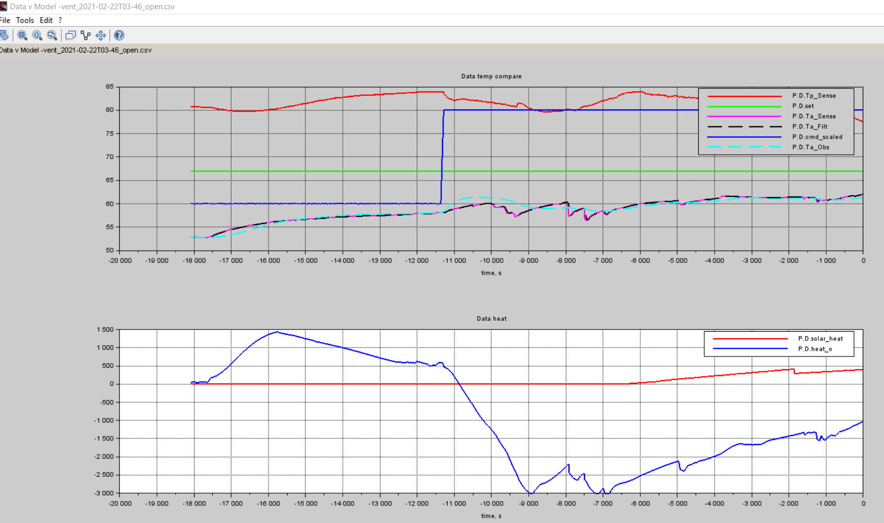

About 2000 sec time constant for convection effect. Probably started out at 2500 BTU/hr input, 68F in kitchen, 53 in sunshine room. ~160 BTU/hr/deg. Duction is at risk of shutting that flow down. That may be part of non-min phase response. Tw actually 60F measured at end of this run. Model predicts 65.8F. So wall model part of solution to the poor data match. Should focus next on the Vent_data_match runs for this zero heat transient. The observed time constant also predicts at conv heat gain value. Also there appears to be a sensing lag of about 600 seconds in heat_o. That’s likely the closed loop bandwidth of the tracker and it is hiding the true response. The Vent_data_match runs have an Qmatch calculation that is not dynamic. 2000 sec 🡪 37 BTU/hr/deg. Start with 50 BTU/hr/deg and construct a first order lag, Rev 1c.

Here’s the match run: heat on at -11500.

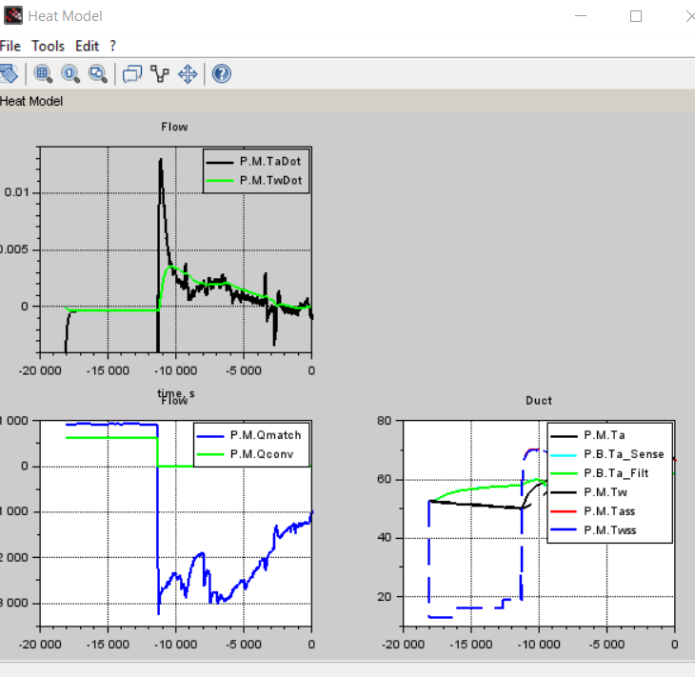

Clearly an additional 1000 Btu/hr convection is happening than modeled. And Twall is probably way off too requiring an additonal 1500 Btu/hr additional heat flow in heat_o. This is going to take time to tune this model.

Presently Rsa = 0.318 F/(Btu/hr). The Ta-OAT initially is about (53-13)=40F. Total wall flux in present model is 126 Btu/hr. The Qlk is 800. Hmmm. Will need to adjust R22 most likely because windows are about R4. So I’ll start by using R12 instead of R22. That will be rev 1a.

That run shows Tw now 66 at end of run. Really was 60 and before model said 68. So now use R4. Rev 1b. Tw now 63.5. OK let’s tune something else.

Add good convection model instead of stupid scalar. Rev 1c. Start with 50 BTU/hr/deg and construct a first order lag, Rev 1c. Also Qlk has opposite sign. Had been used too much as fudge factor. And heat actually leaks into room from kitchen through wall. The solution Tass with Gconv=0 and mdot=0 illustrates Qlk must be a positive number.

When first start up duction there is a large residual heat in the ducting that is too hard to model for this simple model. So I ignore the cold startup transient data once duty turns on.

Feb 23, 2021

So bunch of tuning. Big mess. Added t_door_* timers to match up with transients. Added convection model:

Qconv = (M.Tk - Ta)*M.Gconv; // Replaces old convection model. M.Tk = 68; M.Gconv = 50; BTU/hr/F

And

Tass = max((mdot*M.Cpa*M.Rsa*Tdso + OAT - M.Qlk*M.Rsa + M.Tk*M.Gconv*M.Rsa) / (mdot*M.Cpa*M.Rsa + M.Gconv*M.Rsa + 1), OAT);

Also changed wall resistance to R4;

And scaled duct flow to better match data. M.Smdot = 0.4;

Qduct = M.Smdot*(-0.005153*%cmd^2 + 2.621644*%cmd); *// CFM*

dQ_dCmd = M.Smdot*(2*(-0.005153)*%cmd + 2.621644);

The running transient result:

run_name = 'vent_2021-02-17T04-00_open_open_100';force_init_ta = %t; dTw_init = 0; M.t_door_close = -20741; M.t_door_crack = -17130; M.t_door_open = -11000; M.Qlk = -200; M.Smdot = 0.4; *// close door ; crack door ; open door*

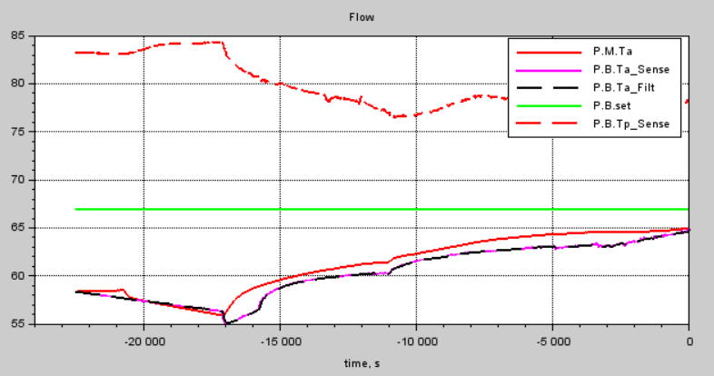

Now the fan off stuff:

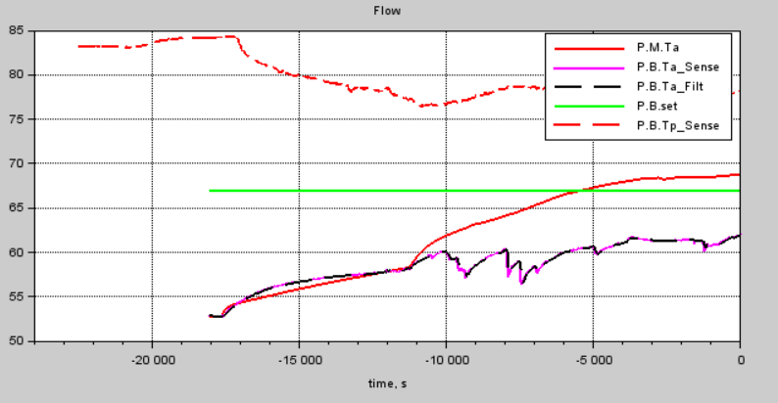

Note big disagree when first turn fan on with doors open at -11000. There is an enormous heat soak effect in the ducting that is difficult to model so I don’t try.

Now let’s add stuff to Photon model and try again. Also using Qlk as model match floater. Qlk = 0 in model on Photon.